

**Proposal / Application**

**for**

**Final Year Project**

**Computer & Information Systems Engineering Department**

**“Air Writing with Finger Detection”**

**Submitted by : Insiyah Talib Hussain (CS-18044)**

**NED University of Engineering & Technology**

# 

# Project Identification

1. **Reference Number** (for office use only)

|  |  |  |  |  |  |  |
| --- | --- | --- | --- | --- | --- | --- |
| **C** | **S** | **-** | **1** | **8** |  |  |

1. **Project Title**

**< Air Writing with Finger Detection >**

1. **Project Internal Advisor**

|  |  |
| --- | --- |
| Name | **Umar Iftikhar** |
| Designation | **Lecturer** |

1. **Project Internal Co-Advisor**

|  |  |
| --- | --- |
| Name | **-** |
| Designation | **-** |

1. **Project External Advisor**

|  |  |  |
| --- | --- | --- |
| Name | **-** | |
| Designation | **-** | |
| Organization | **-** | |
| Mobile # | **-** | Email: - |

1. **Student Team**

|  |  |  |  |
| --- | --- | --- | --- |
| **S. No.** | **Roll No.** | **Name** | **Email** |
| 1. | CS-18044 | Insiyah Talib Hussain | hussain4103731@cloud.neduet.edu.pk |
| 2. | CS-18051 | Arouba Mushtaq | arouba4100714@cloud.neduet.edu.pk |
| 3. | CS-18072 | Raheen Ahmed | ahmed4106726@cloud.neduet.edu.pk |
| ~~4.~~ | CS-18126 | Saima Ali | ali4100134@cloud.neduet.edu.pk |

*Please write down the name of group lead at S. No. 1*

1. **Sponsoring Organization** (if any) - NILL
2. **Keywords**

Air Writing, Alpha-numeric Character Recognition, Finger Tracking, Computer Vision

1. **Project Idea**

* New  Modification to a previous project

❑ Extension of a previous project

1. **ABSTRACT**

Writing in air has been one of the most fascinating and challenging research areas in field of image processing and pattern recognition in the recent years. Several research works have been focusing on new techniques and methods that would reduce the processing time while providing higher recognition accuracy. We are building a software that can be used for creating, recognizing and visualizing alphanumeric data in air. It converts the hand movements in air into a sequence of x, y coordinates on a 2D Cartesian plane, and visualizes them on a canvas, provides a recognition module to predict the content created in air. We will be using EMNIST dataset for training ,it is a set of hand-drawn alphanumeric images which will help our model predict/recognize the characters drawn in the air. Our FYP is contribution towards the idea that how we can use web-cam that recognizes the air-written characters with utmost accuracy, which brings an alternative to stylus and graphical tablets used for whiteboard and other writing platforms.

1. **Project Background and Literature Review**

Recognizing air finger-writing is a difficult and open problem in computer vision, due to the various challenges outlined in the previous section. We review the previous research works related to this work as follows: (1) fingertip detection and tracking; (2) air-writing recognition; and (3) the existing hand datasets related to air-writing recognition.

The use of touch screens in mobile phones has made it difficult for elderly people to use these devices. Elderly people find it difficult to type text on mobile phones. But it will be more convenient if they can physically draw the gesture corresponding to that alphabet in air. Drawing such gestures in air is a recently emerging field in recent times. In this system, a combination of computer vision and convolution neural networks is used for alphanumeric and recognizing it.

1. **Motivation and Need**

Recent advances of tracking technology make it possible to track hand and finger motions without user worn devices, and writing motion is no longer restricted on a physical plane. Air-writing provides a viable alternative interface for text input, particularly when conventional input devices, such as a keyboard or a mouse, are not available or suitable. Compared to other non-traditional input methods such as typing with a virtual keyboard or similar schemes, air writing offers the advantage of “eye-free” execution, requiring minimum attention focus.

Air-writing digit recognition empowers users to communicate with the machine and interact naturally with no mechanical gadgets.

Air-writing is the process of writing characters or words in free space using finger or hand movements without the aid of any hand-held device.

1. **Objectives**

* To implement Air Writing Interface
* To develop accurate finger tracking
* It can be a vital component in improving the user experiences
* Implements interface which requires minimum attention focus

1. **Methodology and Equipment/Tools**

**Tools:**

*Python

*OpenCV

**Technologies:**

*We either need computers which help functioning of large image datasets or Online platforms like Google Colab which provide GPUs/TPUs

*Webcam

1. **Key Milestones and Deliverables**

|  |  |  |  |  |
| --- | --- | --- | --- | --- |
| **No.** | | **Elapsed time (in months) from start of the project** | **Milestone** | **Deliverables** |
| 1. | 1 month | | Dataset Collection and Data Pre-Processing | Handwritten Alpha-numeric images |
| 2. |  | | Design Document | Documentation of the project |
| 3. | 1.5 months | | Finger Tracking Module | We will get a software which tracks finger movement |
| 4. | 1.5 months | | Window Based Writing Event Detection | The user will be able to draw characters on the screen |
| 5. | 1 – 1.5 month | | Writing Event to Word conversion (Detected Handwriting) | This module converts the drawn characters from user into text/word. |
| 6. | 3 months | | Recognition (Feature Processing and Extraction) | Choosing a model which predicts the air written characters |
| 7. | 1.5 – 2 months | | Recognized Handwriting (Test Cases) | Testing the model by drawing characters and checking its prediction and fixing issues |

1. **Expected Outcome**

We will have an interface where user gives an input by making finger movements in air which is known as “Air – Writing” and by choosing suitable models and algorithms our interface will be able to predict the air written characters.

Software provides writing characters in free space by making hand or finger movements without the aid of any hand-held device.

1. **Direct Customers / Beneficiaries of the Project**

* Professionals of educational institutes
* Professionals of business field
* Elderly people who have difficulty with typing
* people who have difficulty using digital whiteboards (due to in availability of stylus, graphical tablets and digital pens)

1. **Consent of Advisors**

**Consent of the Internal Advisor** Signature:

**Consent of the Co-Internal Advisor** Signature:

**Consent of the External Advisor (if any)** Signature:

1. **Reviewers Committee’s Comments**

|  |
| --- |
|  |
|  |
|  |
|  |
|  |
|  |
|  |
|  |
|  |
|  |
|  |
|  |
|  |
|  |
|  |
|  |
|  |
|  |
|  |

1. **Project Schedule / Milestone Chart**

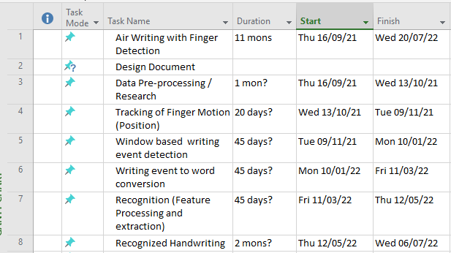

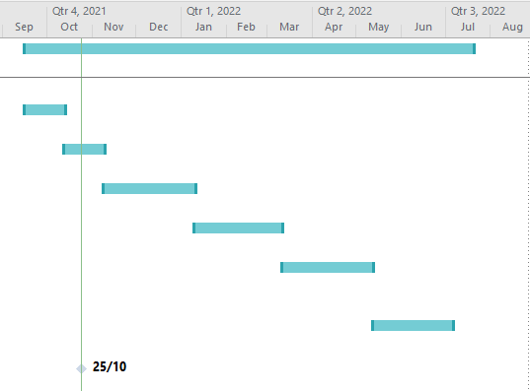

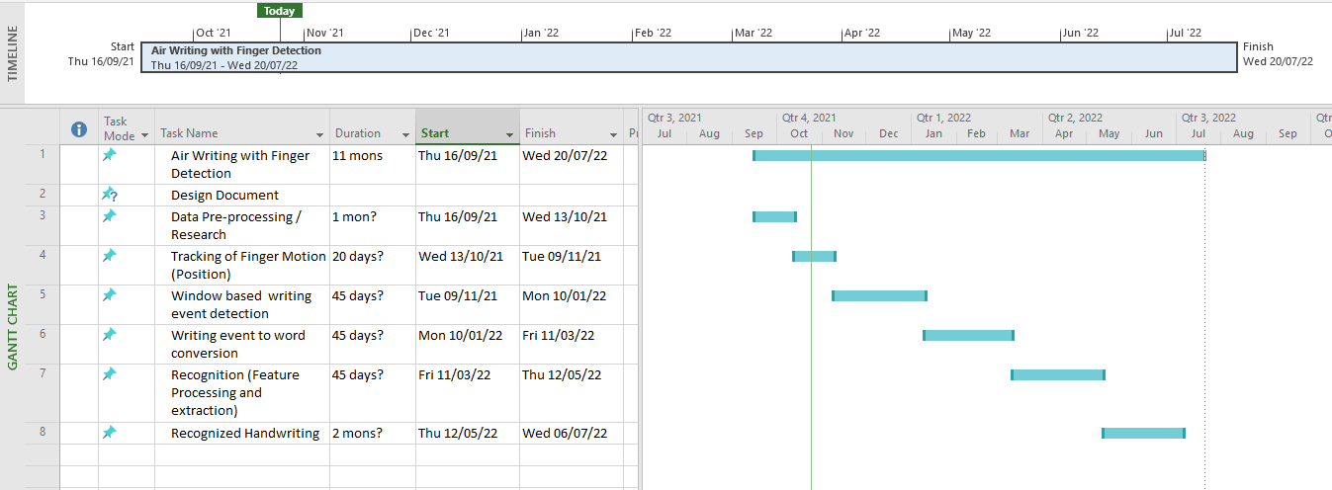

1. **Project Approval Certificate**

**Recommendation of FYP Coordinator** Signature:

**Approval by the Chairman** Signature: